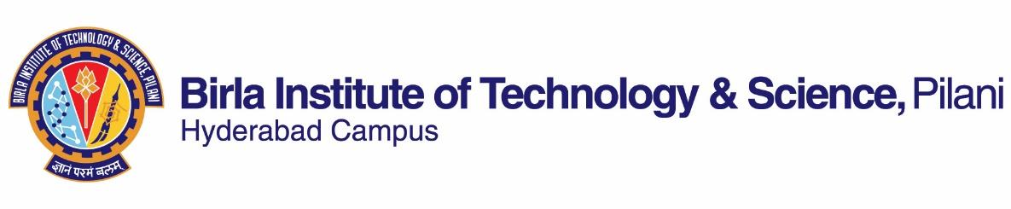

**FIRST SEMESTER 2022-2023**

# Course Handout Part II

Date: 29-08-2022

In addition to part-I (General Handout for all courses appended to the time table) this portion gives further specific details regarding the course.

*Course No.* : HSS F232

## Course Title : Introduction to Development Studies

## Instructor-in-Charge : Suchismita Satpathy

**Scope and Objective of the Course:** This interdisciplinary course introduces students to the history, meanings and theories of development and examines how these theories have been applied to different countries and to different aspects of ‘development’ and in doing so, discusses and evaluates India’s development record in comparison to other developing countries. The objective is to familiarize students with the conceptual, theoretical and empirical tools to understand and appreciate the multi-faceted aspects of development, to question received wisdom, and perhaps contribute in small ways to building a more humane society.

**Reading material:**

1. Chapter 1, 2, and 5 from Goldin, Ian (2018). Development: a very short Introduction. Oxford: Oxford University Press Publication
2. Selected readings from Desai, V., and Potter, R. B. (2014). Companion to Development Studies: Approaches, Actors and Issues (3rd edition). London: Routledge.
3. Selected readings from Peet, Richard & Hartwick, Elaine (2009). Theories of Development Contentions, Arguments, Alternatives Second Edition New York, London: The Guilford Press
4. Selected readings from Currie-alder, Bruce. Kanbur, Ravi. Malone, David M. & Medhora Rohinton. (Eds.) (2014).International Development Ideas, Experience, and Prospects. Oxford: Oxford University Press Publication

**Course Plan:**

|  |  |  |  |
| --- | --- | --- | --- |
| **Lecture No.** | **Learning objectives** | **Topics to be covered** | **Chapter in the Text Book** |
| 1 | Understand the History of development, meanings of development | The context underlying the evolution of Development | RM1. Chs.1, 2 |
| 2-10 | Discuss the Key development  Thinkers. | Smith, Marx, Liszt, Keynes, Prebisch, Friedman | Reading materials will be provided in class |
| 11-20 | Analyse 20th century perspectives on development and assess the core aspects of non-conventional theories, their analytical differences, strategies for development | Dependency, modernization, human development, post- and anti-development  theories;  Marxism, socialism, dependency theories, post-development, alternatives to development | TB Ch 2  Reading materials will be provided in class |
| 21-29 | Assess the conventional theories, their evolution, progress and consolidation as a strategy for economic development | Models of development: ISI and neoliberalism; Classical, neoclassical, Keynesianism and neoliberalism | TB ch.4 |
| 30-37 | Identify and ascertain the nature of Themes in comparative international development, dimensions and varying impacts of some of the structural development issues | Environment, health,  gender, foreign aid, social and human rights. | TB 5, 6  Reading materials will be provided in class |
| 37-39 | Evaluate India’s development experience | Development performance of India, regional variations, development models | TB ch 7, 8 |
| 40-41 | Discuss and evaluate India’s development in a comparative perspective | India’s development performance compared with other developing countries | Reading materials will be provided in class |

**Evaluation Scheme:**

|  |  |  |  |  |
| --- | --- | --- | --- | --- |
| **Component** | **Duration** | **Weightage (%)** | **Date & Time** | **Nature of Component** |
| Assignment 1 | TBA | 15 | TBA | Open book |
| Mid semester test | 90 minutes | 30 | 01/11/2022  3.30 - 5.00 PM | Close Book |
| Assignment 2 |  | 15 | TBA | Open Book |
| Comprehensive examination | 3 hours | 40 | 21/12/2022 AN | Close Book |

**Chamber Consultation Hour:** K-126, Tuesday and Thursday 4.30- 5.30

**Notices:** Notices, if any, will be displayed on CMS

**Make-up Policy:** The make-up for an evaluation component will be given only in genuine cases. In health related issues student has to bring a letter from warden as per the latest SWD guidelines**.**

**Academic Honesty and Integrity Policy:** Academic honesty and integrity are to be maintained by all the students throughout the semester and no type of academic dishonesty is acceptable.

**Suchismita Satpathy**

**INSTRUCTOR-IN-CHARGE**